**Load testing for Orange Hrm Application using JMeter**

1. Creating project called OrangeHrmApplication

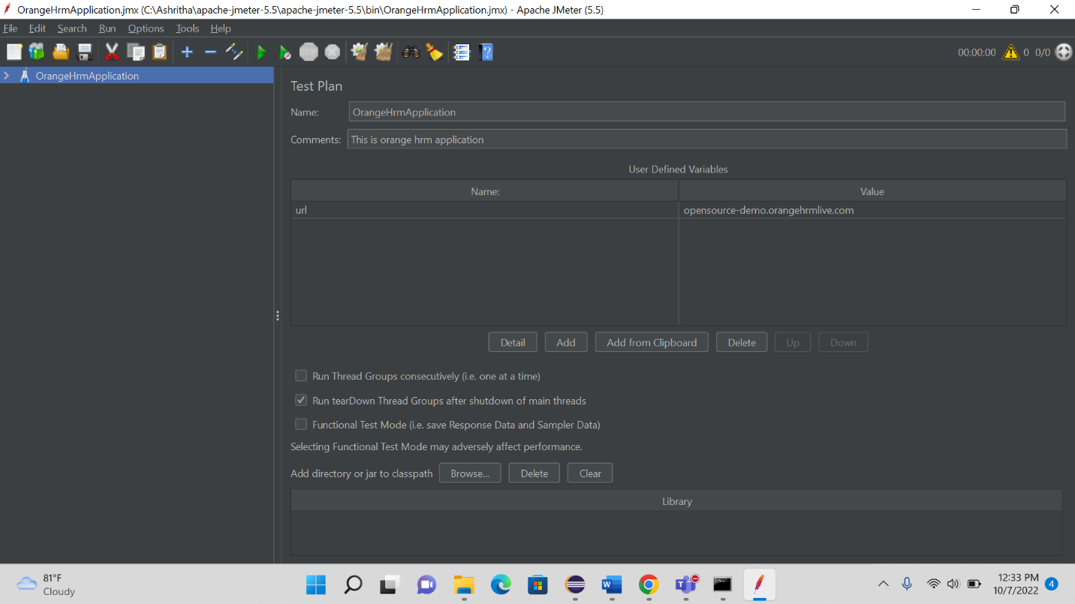

1. Adding Thread group to the project with 25 users and 2 times performing load testing.

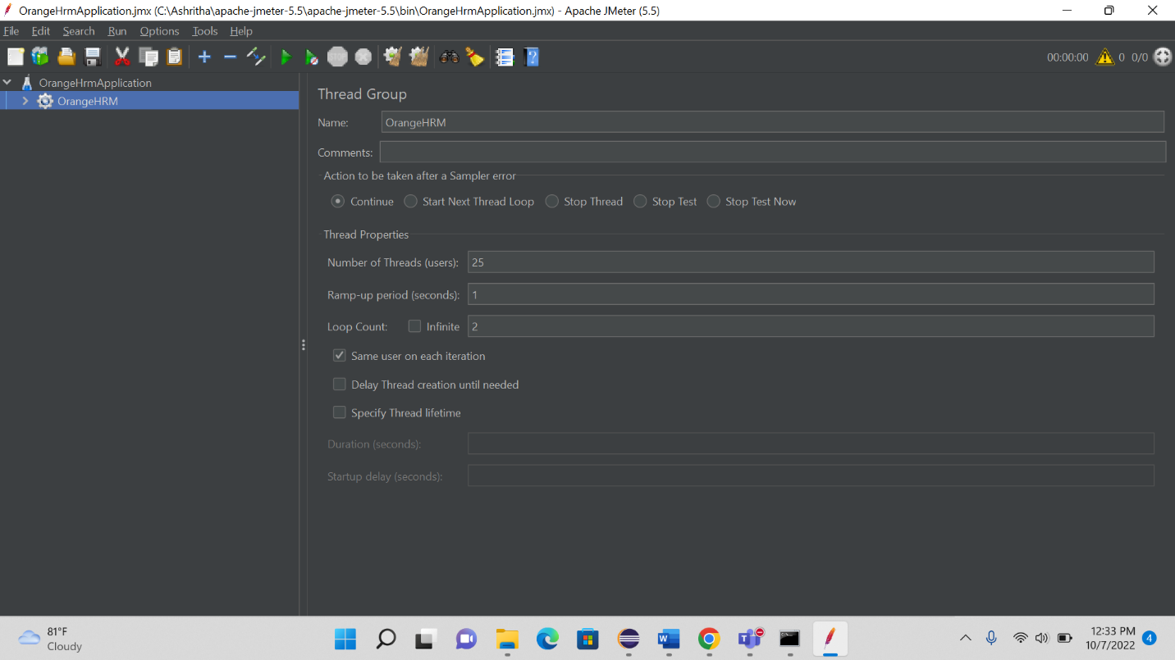

1. Adding 5 sampler to the Thread group

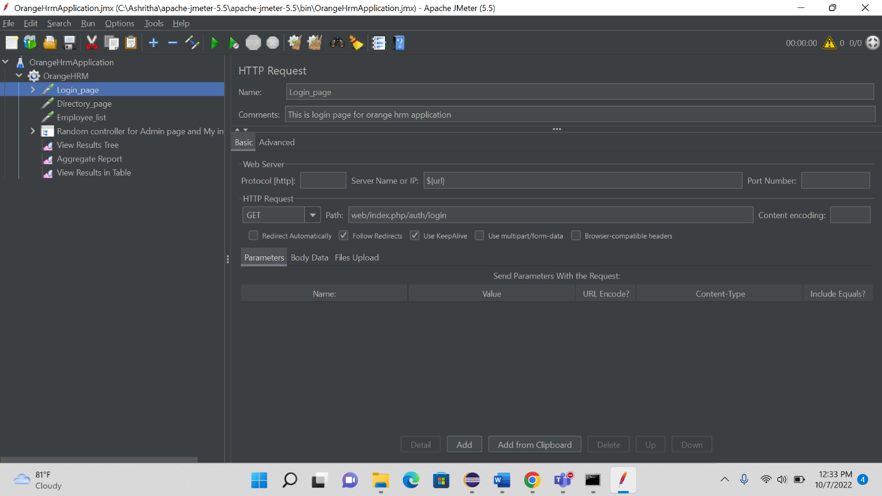

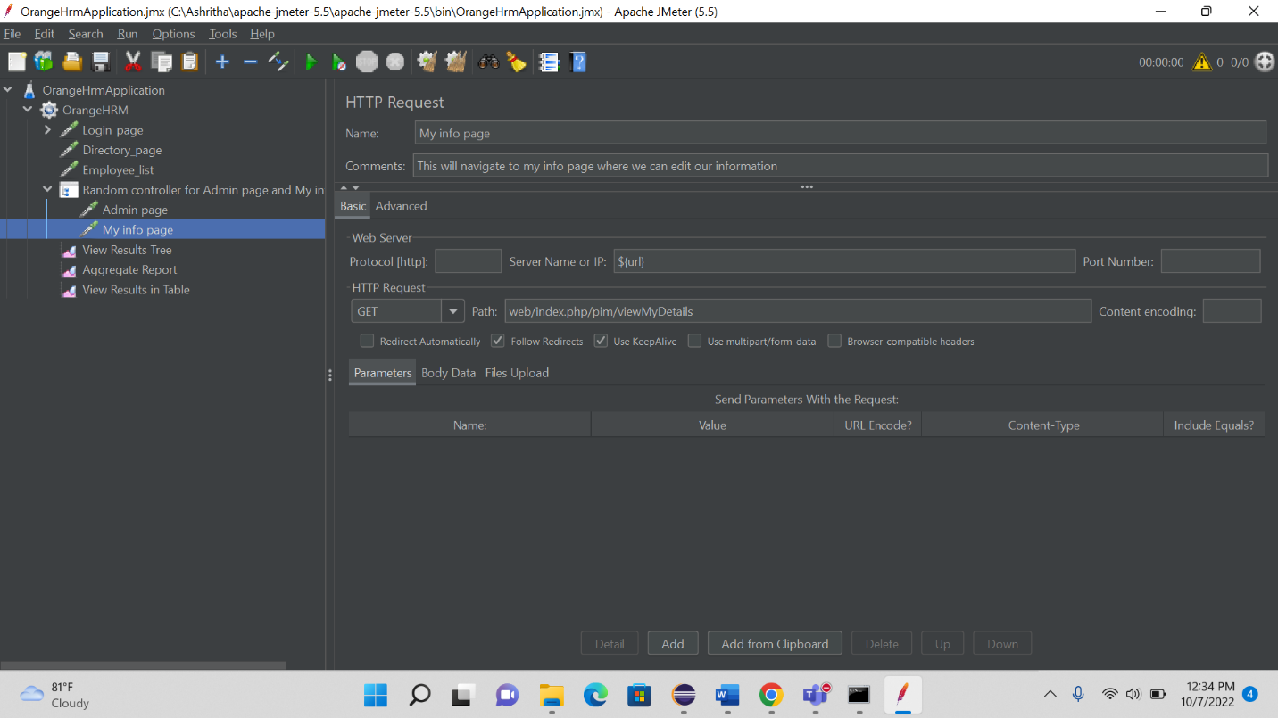

1. Adding Random controller for Admin page and My info page

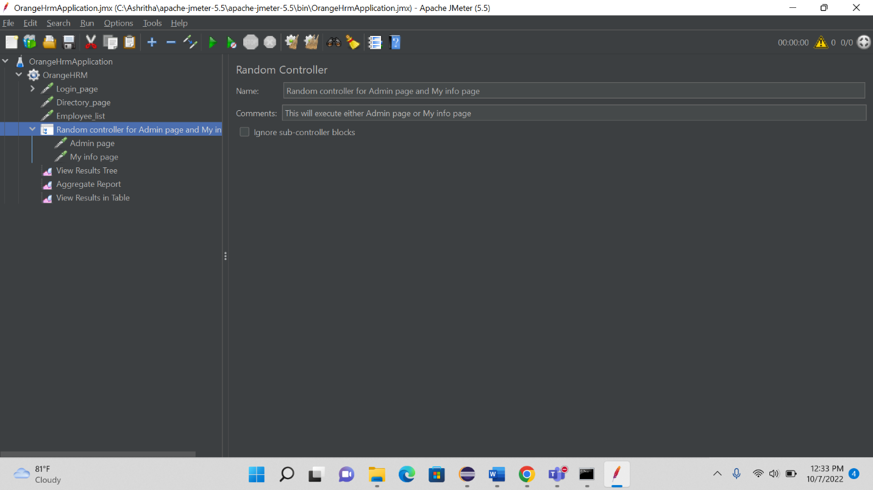

1. Adding Response Assertion to login page

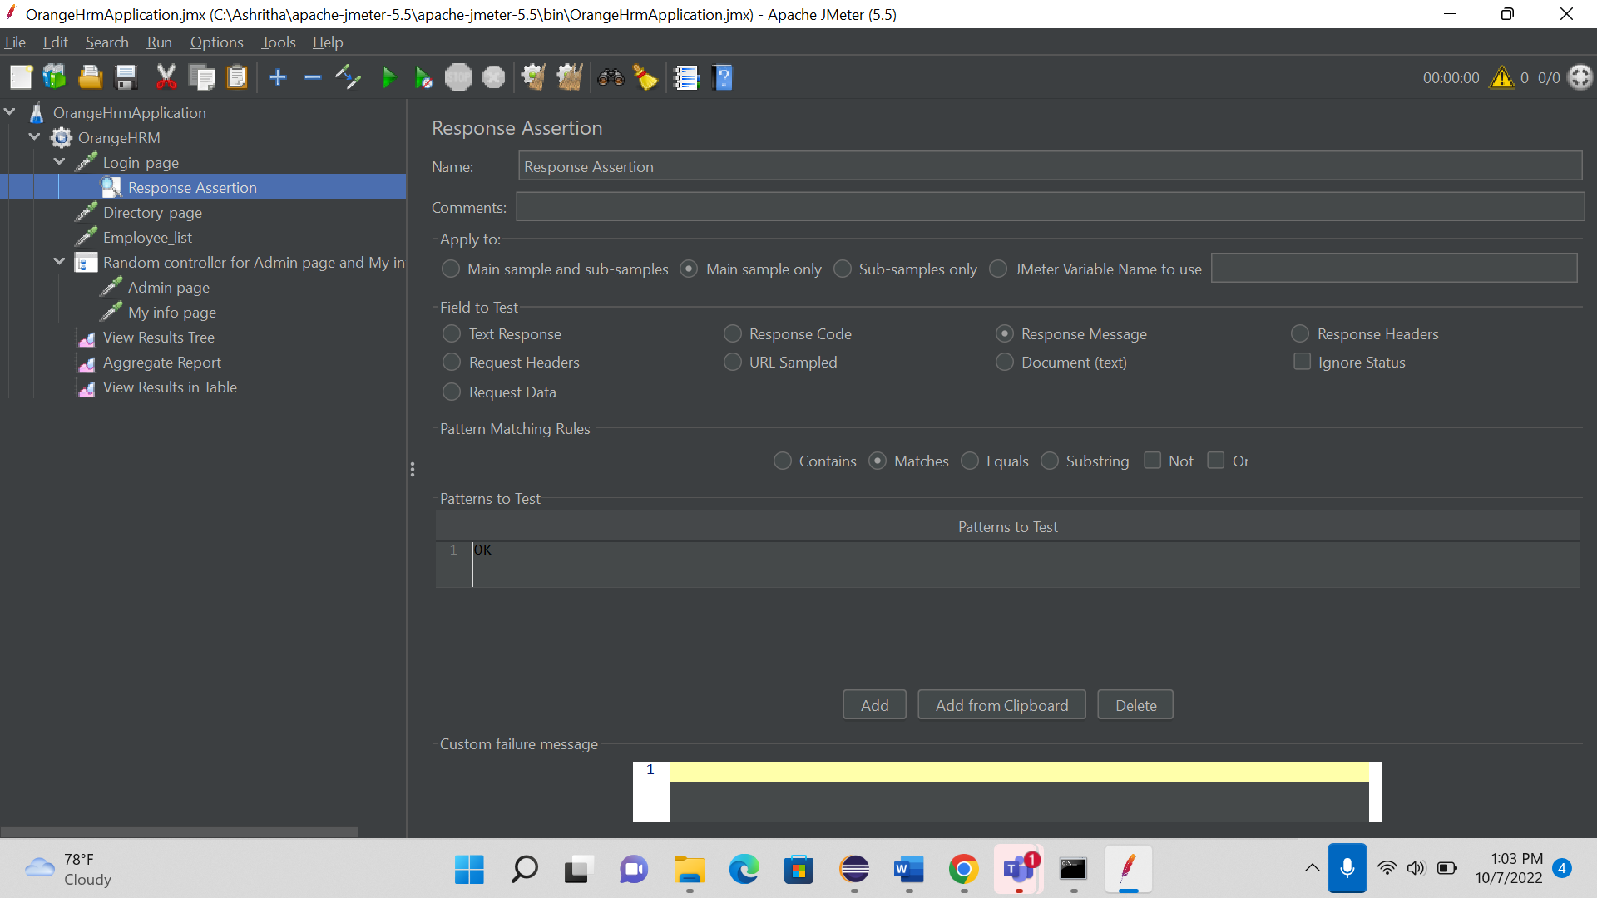

1. Adding 3 Listeners to Thread group

1. Output of JMeter

